**DSA Practice Problems**

**Set - 6**

1. **Bubble Sort:**

Given an array, **arr[]**. Sort the array using bubble sort algorithm.  
**Input**: arr[] = [4, 1, 3, 9, 7]

**Output**: [1, 3, 4, 7, 9]

**Code**:

class Solution {

// Function to sort the array using bubble sort algorithm.

public static void bubbleSort(int arr[]) {

// code here;

int temp;

for(int i=0;i<arr.length-1;i++){

for(int j=i+1;j<arr.length;j++){

if(arr[i]>arr[j]){

temp = arr[i];

arr[i] = arr[j];

arr[j] = temp;

}

}

}

for(int num:arr){

}

}

}

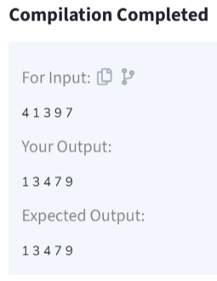

**Time Complexity: O(n^2)**

1. **Non Repeating Character:**

Given a string **s** consisting of **lowercase**Latin Letters. Return the first non-repeating character in **s**. If there is no non-repeating character, return **'$'.**  
Note:When you return '$' driver code will output -1

**Input:** s = "geeksforgeeks"

**Output:** 'f'

**Explanation:** In the given string, 'f' is the first character in the string which does not repeat.

**Code:**

class Solution {

// Function to find the first non-repeating character in a string.

static char nonRepeatingChar(String s) {

int n = s.length();

for (int i = 0; i < n; ++i) {

boolean found = false;

for (int j = 0; j < n; ++j) {

if (i != j && s.charAt(i) == s.charAt(j)) {

found = true;

break;

}

}

if (found == false)

return s.charAt(i);

}

return '$';

}

}

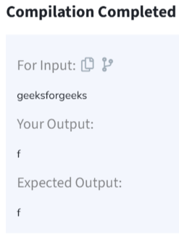

**Time Complexity: O(n^2)**

1. **Quick Sort:**

Implement Quick Sort, a Divide and Conquer algorithm, to sort an array, **arr**[] in ascending order. Given an array, **arr**[], with starting index **low** and ending index **high**, complete the functions **partition()** and **quickSort()**. Use the last element as the pivot so that all elements less than or equal to the pivot come before it, and elements greater than the pivot follow it.

**Note**: The **low** and **high** are inclusive.

**Input:** arr[] = [4, 1, 3, 9, 7]

**Output:** [1, 3, 4, 7, 9]

**Code:**

class Solution {

// Function to sort an array using quick sort algorithm.

static void quickSort(int arr[], int low, int high) {

// code here

if (low < high) {

int pi = partition(arr, low, high);

quickSort(arr, low, pi - 1);

quickSort(arr, pi + 1, high);

}

}

static void swap(int[] arr, int i, int j) {

int temp = arr[i];

arr[i] = arr[j];

arr[j] = temp;

}

static int partition(int arr[], int low, int high) {

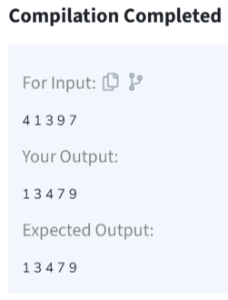 // your code here

int pivot = arr[high];

int i = low - 1;

for (int j = low; j <= high - 1; j++) {

if (arr[j] < pivot) {

i++;

swap(arr, i, j);

}

}

swap(arr, i + 1, high);

return i + 1;

}

}

**Time Complexity: Best Case: (Ω(n log n)), Average Case (θ(n log n)), Worst Case: (O(n²))**

1. **Edit Distance:**

Given two strings s1 and s2. Return the minimum number of operations required to convert s1 to s2.

The possible operations are permitted:

Insert a character at any position of the string.

Remove any character from the string.

Replace any character from the string with any other character.

**Input:** s1 = "geek", s2 = "gesek"

**Output:**1

**Explanation:** One operation is required, inserting 's' between two 'e'.

**Code:**

class Solution {

public int editDistance(String s1, String s2) {

int m = s1.length(), n = s2.length();

int[][] dp = new int[m + 1][n + 1];

for (int i = 0; i <= m; i++) dp[i][0] = i;

for (int j = 0; j <= n; j++) dp[0][j] = j;

for (int i = 1; i <= m; i++) {

for (int j = 1; j <= n; j++) {

if (s1.charAt(i - 1) == s2.charAt(j - 1)) {

dp[i][j] = dp[i - 1][j - 1];

} else {

dp[i][j] = Math.min(

dp[i - 1][j - 1], // Replace

Math.min(dp[i][j - 1], dp[i - 1][j]) // Insert or Delete

) + 1;

}

}

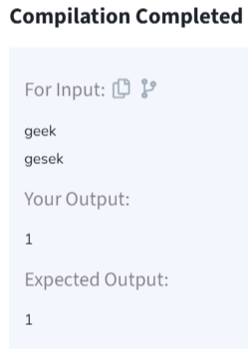 }

return dp[m][n];

}

}

**Time Complexity: O(n)**

1. **K Largest Element:**

Given an array **arr[]** of positive integers and an integer **k**, Your task is to return **k largest elements**in decreasing order.

**Input:** arr[] = [12, 5, 787, 1, 23], k = 2

**Output:** [787, 23]

**Code:**

class Solution {

// Function to find the first negative integer in every window of size k

static List<Integer> kLargest(int arr[], int k) {

List<Integer> list = new ArrayList<>();

for (int num : arr) {

list.add(num);

}

Collections.sort(list, Collections.reverseOrder());

return list.subList(0, k);

}

}

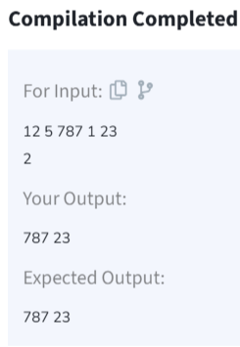

**Time Complexity: O(nlogn)**

1. **Form the Largest Number:**

Given an integer **N** the task is to find the largest number which is smaller or equal to it and has its digits in non-decreasing order.

**Input:** N = 200

**Output:** 199

**Explanation:**

If the given number is 200, the largest number which is smaller or equal to it having digits in non-decreasing order is 199.

**Code:**

class Solution{

static int find(int N){

char[] digits = String.valueOf(N).toCharArray();

int length = digits.length;

int i;

for (i = 1; i < length; i++) {

if (digits[i] < digits[i - 1]) {

break;

}

}

if (i == length) {

return N;

}

while (i > 0 && digits[i - 1] > digits[i]) {

digits[i - 1]--;

i--;

}

for (int j = i + 1; j < length; j++) {

digits[j] = '9';

}

return Integer.parseInt(new String(digits));

}

}

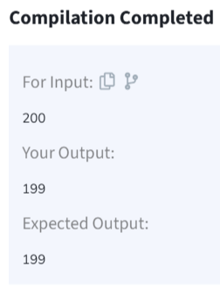

**Time Complexity: O(n)**